**AI in Healthcare**

Simulation harder

Experimentation expensive, limited and can have harmful consequences (potentially lethal)

Feedback could take years and could be unreliable (lots of uncontrollable variables, could be long term consequences to things)

Data often non-existent

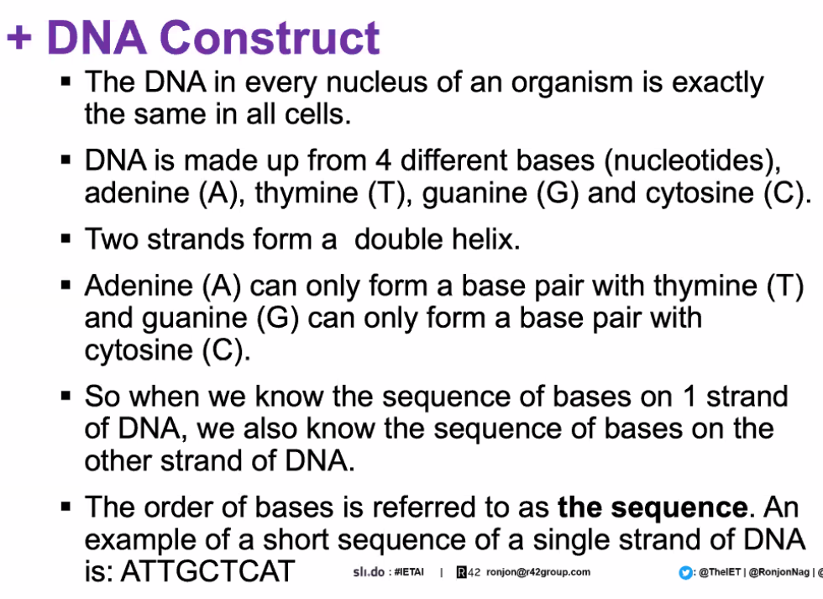

DNA -> RNA -> Proteins

New theory: Genes are ‘expressed’ depending on the environment (not just fixed), polygenic approach (with multiple genes effecting traits and performance), effected by environment and lifestyle

-still certain genes that are associated with various diseases. Some heavily based on one (like Huntington’s), but most indicated by multiple

-things caused by genes, or not prevent by missing/damaged gene?

**Animals**

Naked mole rat makes acid that protects against cancer

Bats very long lived, and can be very active immediately after waking

**Telomeres**

Protect DNA strands, but get smaller and smaller over time

**Biomarkers**

BMI

Fasting glucose levels

Telomere length

Waist size

Etc.

**Medical Databases**

MD.AI

Single Mechanism causing aging? Or more like a car with various bits breaking down over time

**Personalised Medicine**

All bodies slightly different, medicines could be more effective if tailored to consider these differences

**Large vs Small Molecules**

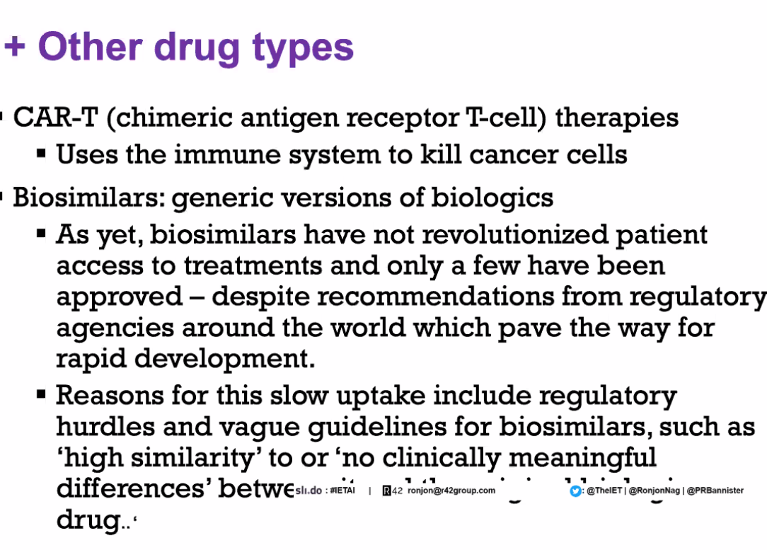

**Drug Approval**

Very expensive

10-15 years

Several phases of clinical trials

-Pre-phase 1 5% chance of commercial viability

**Ethics**

Privacy, unfairness, bias

Correlation, rather than causation

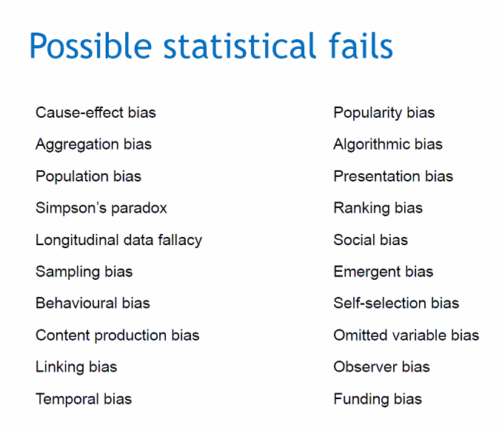

What question is the AI trying to answer?

-is it completely unambiguous?

What data is it using?

Is it’s result reflective of any causation